Chapter 18, Solution 23.

(a) f(3t) leads to 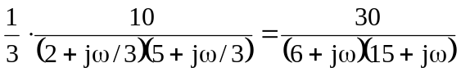
F 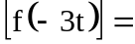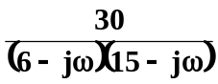

(b) f(2t) 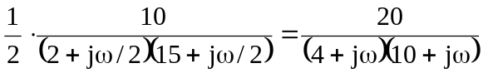
f(2t-1) = f [2(t-1/2)] 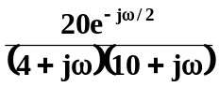
(c) f(t) cos 2t 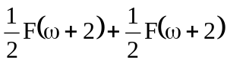
= 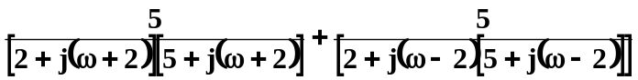

- F 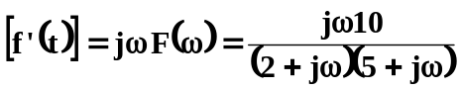

(e) 
 